**HISTOGRAM EQUALIZATION**

**Read the image:**

f=imread('Chrysanthemum.jpg');

imshow(f);

title('Original image');

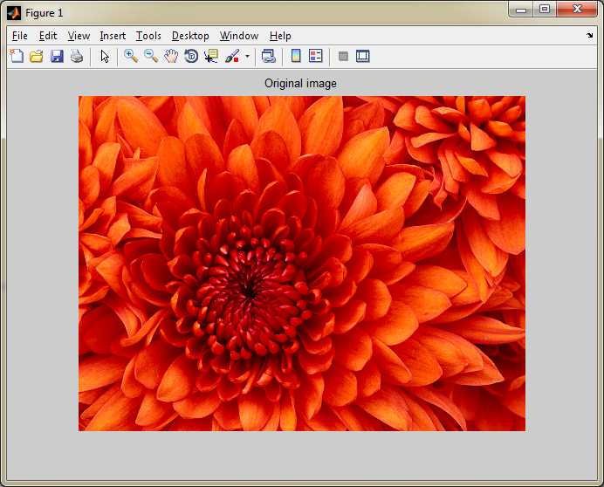

**Perform histogram equalization and obtain the histogram:**

g=rgb2gray(f);

i=histeq(g);

g2=adapthisteq(g,'Numtiles',[25,25],'Cliplimit',0.05);

subplot(2,2,1);

imshow(g);

title('Gray image');

subplot(2,2,2);

imhist(i);

title('histrogram');

subplot(2,2,3);

imshow(g2);

title('Adapt Equalization');

subplot(2,2,4);

imhist(g2);

title('Adapt Equalization histogram');

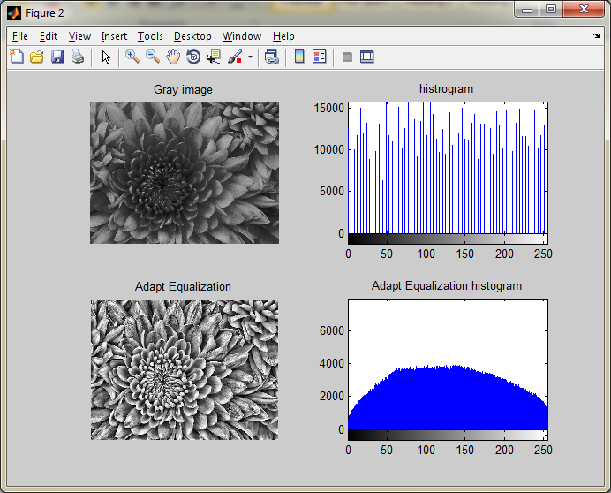

**Perform histogram matching:**

k=histeq(g,256);

subplot(1,2,1);

imshow(k);

title('Histogram matching');

subplot(1,2,2);

imhist(k);

